Smart House Remote Control
System Requirements Specification

Smart House
Smart House Remote Control
Or Golov
31/12/12
Ver 2.0

______________________________
[Project Lead Signature Block]

______________________________
[Project Manager Signature Block]

TABLE CONTENTS
1 Introduction 4
1.1 Purpose 4
1.2 Scope 4
1.3 Definitions, Acronyms, and Abbreviations 5
1.3.1 Key Definitions 5
1.3.2 Key Acronyms and Abbreviations 6
1.4 Key References 6
1.5 System Overview 6
2 Overall description 8
2.1 Product perspective 8
2.1.1 System interfaces 9
2.1.2 User interfaces 9
2.1.3 Hardware interfaces 9
2.1.4 Software interfaces 9
2.1.5 Communications interfaces 9
2.1.6 Memory 10
2.1.7 Operations 10
2.1.8 Site adaptation requirements 10
2.2 Product functions 11
2.2.1 Local site command execute (local application command) 11
2.2.2 Remote site command execute (edge application command) 12
2.2.3 Set Policies to the smart house (on local application) 13
2.3 User characteristics 13
2.4 Constraints 14
2.5 Assumptions and dependencies 16
2.6 Apportioning of requirement 16

Revision Sheet

Revision Number | Date | Brief summary of changes
01 | 09/12/12 | Creation of the document.
02 | 31/12/12 | Fixed typo error.  Added the comments from peer review.

Introduction

Purpose
The purpose for this SRS is to create an understanding of the way this project will be implemented, between the Developers to the moderator. It will sum up all the requirements in this project.

Scope
The system has a lot of interfaces and connection to several of different systems, for that reason this part will state which of the systems are in the scope of this project and which may be at the future or not at all.

The project includes 2 main scopes.
Local smart house command and remote smart house commands.

Local smart house:
The system will use smart device manager, smart plugs and smart device that is already works and used in a smart house. All of them have not been chosen yet. The new addition in this project there will be a local application that will run on the center computer in the house, which will be user friendly and contain security defenses.

Local application (runs on the center PC) – this application controls the local house smart plugs. Any device that connects to the smart plug can receive commands from the local application. The functionality of the commands will be limited to basic commands for this version including the following commands "Turn On", "Turn Off". It is the developer choice to add more commands in this version of the project. The local application manages policies of user and commands. The policies manage will support white and black list model. The local application communicates with an application server that sends it remote commands to execute on the house. The local application will verify the server for security reasons and will verify the remote commands using the policy manager.

Remote smart house:
The system will use everything that is mentioned in the local smart house scope and will add to it more systems.

Remote server application (runs over internet server) – The application has a web GUI for the internet user. The web GUI can be used for remote access to the smart house system allowing the user to send command to it. The application will manage users and remote policies. It will allow remote users using smart devices or having a connection to the internet to send commands to the local application. The application will display a web GUI for browsers. The application will verify the user using security policies. The application uses a DB that will be secure and will run over a different server. In case of constraints it can run over the same server.

DB server (runs over internet server) – contains records of all user, houses, devices, and all additional information that is needed for the project to run.

Edge application (will run over smart devices) – This application can be cross platform or it will be implanted with several platform versions such as WindowsApp, LinuxApp, AndroidApp, iOSApp (version TBD). The edge application will identify the user using the Remote server application and connecting him to the remote server. The application uses friendly and simple to use GUI. The main function of this application will be connection to specific house, choosing smart device from a list of devices, send "Turn On" or "Turn Off" command. The application will send commands to the remote server which will then send it to the smart house. The application will return notification if the command succeeded or failed.

The project will not contain wiring, installment or even configuration to any smart devices and their smart plugs. It will be as a "suit solution" to an existing smart house.

Definitions, Acronyms, and Abbreviations

Key Definitions
Cross platform works on several platforms without modification.
Data base a database is a structured collection of data. The data are typically organized to model relevant aspects of reality (for example, the availability of rooms in hotels), in a way that supports processes requiring this information (for example, finding a hotel with vacancies).
Edge application application that runs over PC / Smartphone / Tablet, can send remote
commands to the Server application.
Graphical User Interface A graphical user interface (GUI) is a type of user interface that allows users to interact with electronic devices using images rather than text commands. A GUI represents the information and actions available to a user through graphical icons and visual indicators such as secondary notation, as opposed to text-based interfaces, typed command labels or text navigation. The actions are usually performed through direct manipulation of the graphical elements.
Internet Protocol The Internet Protocol (IP) is the principal communications protocol used for relaying datagrams (also known as network packets) across an internetwork using the Internet Protocol Suite responsible for routing packets across network boundaries. It is the primary protocol that establishes the Internet.
Local application Application that runs over the local PC (in the house), control all the devices in the house. Has connection to the Server application via internet.
Policy A policy is a principle or rule to guide decisions and achieve rational outcomes. A policy is an intent, and is implemented as a procedure or protocol.
Server application Application runs over server in the web. Uses to receive commands from the remote user and send it to the local application.
Smart device Electric device that has an API to control or configure it through
communication protocol such as Wi-Fi, electric network and more.
Smart House system Refers to the entire smart house system with all the smart devices
and the smart plugs.
Smart plug Electric plug that has the ability to perform remote commands sent to it
via communication protocol from the smart device manager.
Transmission Control Protocol The Transmission Control Protocol (TCP) is one of the core protocols of the Internet Protocol Suite. TCP is one of the two original components of the suite, complementing the Internet Protocol (IP), and therefore the entire suite is commonly referred to as TCP/IP. TCP provides reliable, ordered delivery of a stream of octets from a program on one computer to another program on another computer. TCP is the protocol used by major Internet applications such as the World Wide Web, email, remote administration and file transfer. Other applications, which do not require reliable data stream service, may use the User Datagram Protocol (UDP), which provides a datagram service that emphasizes reduced latency over reliability.
Wireless Fidelity Wi-Fi is a popular technology that allows an electronic device to exchange data wirelessly (using radio waves) over a computer network, including high-speed Internet connections. The Wi-Fi Alliance defines Wi-Fi as any "wireless local area network (WLAN) products that are based on the Institute of Electrical and Electronics Engineers' (IEEE) 802.11 standards".

Key Acronyms and Abbreviations
CLI Command Line Interface.
DB Database.
GUI Graphical User Interface.
IP Internet Protocol.
MAC Macintosh.
PC Personal Computer.
SH Smart House.
SHE Smart House Edge application.
SHL Smart House Local application.
SHS Smart House Remote application.
SRS System Requirements Specification.
TBD To Be Declared.
TCP Transmission Control Protocol.
Wi-Fi Wireless Fidelity.

Key References

System Overview
The SRS will describe the basic requirement of the system and several of its major state and condition. It will describe the platforms that are part of the system and their roles.

Overall description
The smart house remote control system is based on an application that will run over an edge platform (such as PC, Smartphone etc.), which could change the state of an electric device connected to the smart device controller.
The communication between the applications to the device will be based on the internet and will be controlled and supervised by a server.
The system will demonstrate this ability and will not have a complete control over all the functionality of the device but only a few basic commands ('Turn On', 'Turn Off' and etc.)

Product perspective

The system includes variety of edge platforms that communicates with the application server through the Internet. The edge platform includes PC, MAC, Smartphone and Tablets. There are also two servers, one for the web / requests through the internet, and the other is for the DB which contains information on the house and its policies (such as users and commands). The application server communicates with the home center PC which commands the local smart devices.
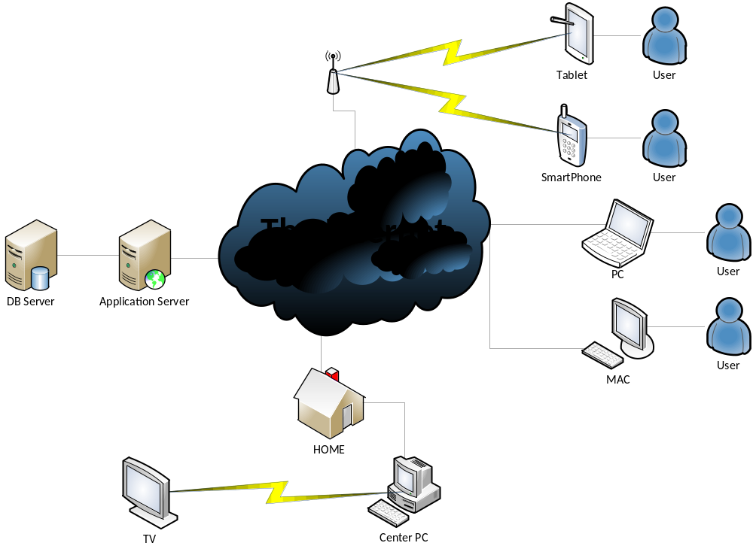

System interfaces
The system will have several interfaces with other systems such as the smart device control manager which is a shelf product with an exterior API. The smart house system will use the smart device control manager in order to operate the commands to the electric devices that are inside the house.
There are also interfaces for the edge platforms, which are the smartphones, tablets, center PC and servers all of them using GUI.

For the center PC and servers there will be also a CLI.

User interfaces
There are varieties of application that are used by the user that connected with the system:
The local PC (in diagram the center PC) – it is located in his house and the user can access it. On the center PC there will be a SHL that will be used by the user.

The remote platform – variety of edge platform all connected to the internet such as smartphone, tablets, remote PC or MAC. The entire above are not connected directly to the smart device manager which is in the smart house. They are connecting to the internet and through it they connect to the remote application. In each of them there will be the SHE with user interface.

Each of the application will have a friendly GUI that can be easy to learn and use.

There is also maintance that can use the CLI in the center PC and in the servers.

Hardware interfaces
Since this project runs on several platforms and uses smart devices as well, then we will regard each of them separately. Also since it only demonstrator it will be valid only for the platforms and their limitation that will be described at section 3.

The hardware interfaces are depndancy of the selected smartphone, tablet, PC and server that had yet been choosen.

TBD

Software interfaces
TBD.

Communications interfaces
The communication section between the systems is as seen in the diagram. The SHE that runs over the edge platform communicates via the Internet with the SHR that runs over the Application server. The SHR communicates with the DB server in order to retrieve information or to store it. The SHR also communicates with the SHL which runs over the local PC (in diagram – center PC), it communicates via the Internet as well.
For all the communication between the applications above the network protocol will be connected as WAN using IP/TCP protocol.
The SHL communicates with the smart device manager which controls the smart devices. In this case the Network protocol will be LAN or another protocol that the smart device manager supports.
The SHL also reports back to the SHR in order to notify it with the latest policies and states of the different devices in the house by using WAN using IP/TCP.

Memory
There are no memory constraints.

Operations
Since this system is only a demonstrator it will not include operations such as backup and recovery or operations that make it go offline/down.

Site adaptation requirements
It is self-complete system the only site adaptation requirement is that the site will have internet connection and electric smart device. The other entire requirements are mentioned above.

Product functions
There are 3 major functions that the system must have, without them the system will not answer its critical requirements.

Local site command execute (local application command)
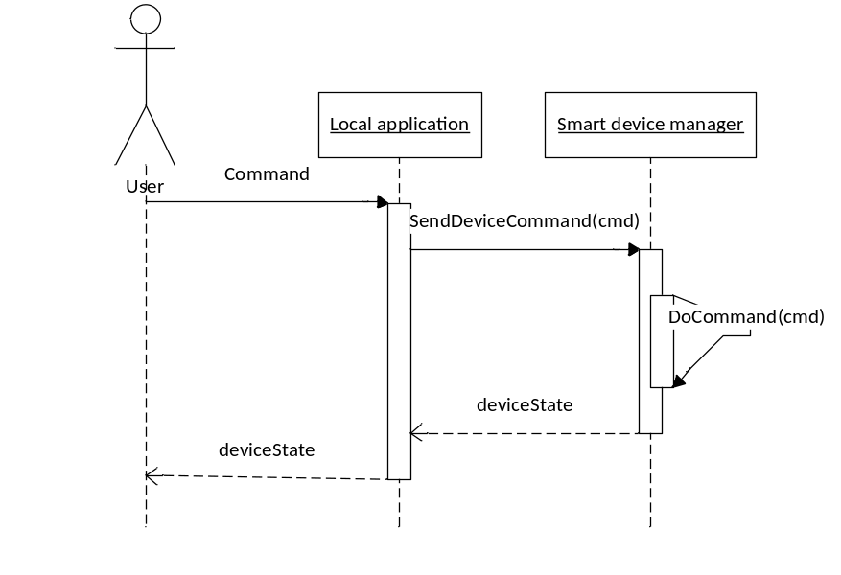
The user will have the ability to use commands and send them to the smart device through the center PC which runs the SHL.
The user will choose a command from the available commands list on one of the smart devices in the house.
After he chooses the command application will send it to the smart device manager that will do it.
After the command happened on the smart device, the smart device manager will send the new state of the smart device to the SHL which will display the state to the user using its GUI.

Remote site command execute (edge application command)
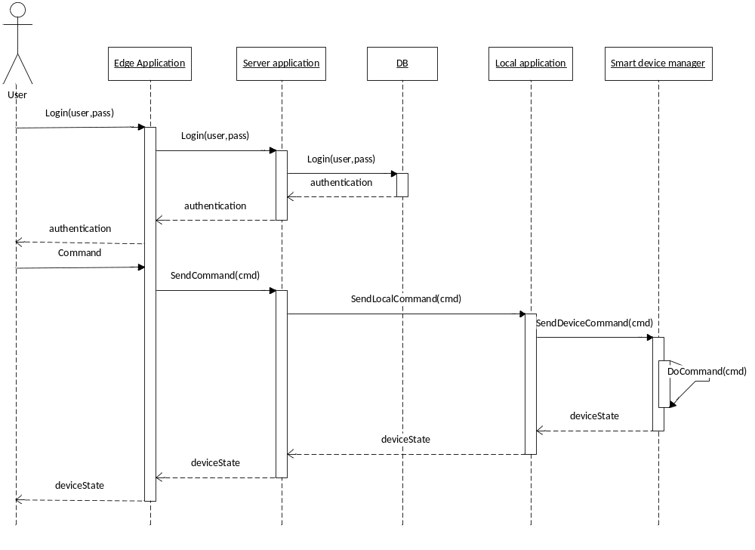
The user will login to the system by using the SHR which will be running on his remote platform (such as smartphone, tablet and etc.).
The login process will be using a user name and password given by the user through a GUI supplied by the SHR.
Then the SHR will send the information to the application server to the SHS in order to authenticate the user.
The SHS will use the DB server to verify the given parameters and will return the verification to the SHR.
After the user completed the login process he will have the ability to use commands and send them to the smart device through the remote platform which runs the SHR.
The user will choose a command from the available commands list on one of the smart devices in the house.
After he chooses the command application will send it to the application server to the SHS. The SHS will verify the command and will send it to the local PC to his SHL.
The SHL will check if that command is valid using polices that the admin user has defined. If the command is verified the SHL will send it to the smart device manager that will do it.
After the command happened on the smart device, the smart device manager will send the new state of the smart device to the SHL which will notify the SHS which notify the SHR that will display it to the user by its GUI.

Set Policies to the smart house (on local application)
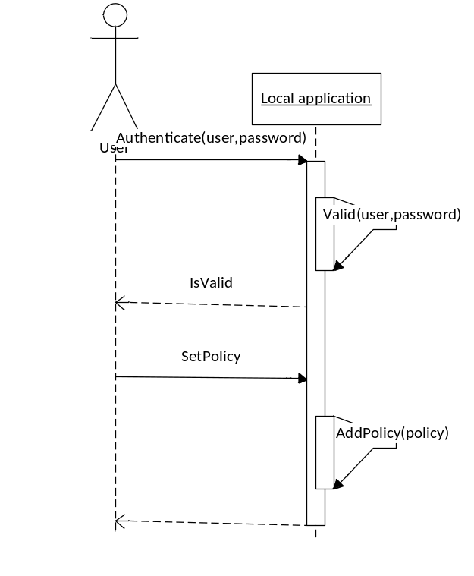
The local user will be able to login in to the SHL as an admin user.
After the login process ended the user will have the ability to set policies to his local smart house system (the full list of types of policies will be displayed at section 3).
The user will set new policy by using the GUI of the SHL. SHL will add it to his policies manager and will display an appropriate message to the user by its GUI.

User characteristics
The majority of the users are the average person who wants to enjoy the simple life of controlling their local electric devices.
There are two groups of users: local and remote.

The local group is users that are physically in the house and have access to the local computer. This group divides into two types of users: admin, regular. Admin user can set policies to this smart house system that will be enforcing by it. Furthermore it can use all the functionally and commands the local application has. The regular user can only use the functionality that the admin set for him.

The second group is the remote user. This group divided to four types of user: PC, MAC, Tablet and Smartphone. They resembles to the regular user in the term of that can only use the command that the admin set for them but the difference is the platform they are using to connect to the server and that they must have an internet connection to it. In addition each of them must login to the system before they can perform any remote command to their local smart house.

Constraints
Each remote user must connect to the system before sending any commands.

User can have more than one house.

The admin user can only connect to the local PC.

Only the admin user can set policy regarding to his local house.

At each house there will be at least one admin user which cannot be deleted.

When local command is sent a notification of the device state will be display to the user in no more than 5 seconds.

When remote command is sent a notification of the device state will be display to the user in no more than 10 seconds.

In the SH system there will be at least two houses architecture that contains center PC with internet connection, device control manager and at least two smart devices.

There will be an application server and a DB server that are connected to the internet.

There will also be a PC or/and MAC with internet connection that will be used as the remote platforms.

Additional interface is the smartphone that has to have internet connection over Wi-Fi or cellular telecommunication.

The tablet will have similar interface such as the smartphone.

The system will support at least connection of 10 remote users sending commands simultaneously to the same local house.

The system will support sending different commands to different devices in the same house simultaneously.

If the system is up and there is a full connection between all the components then each command must be executed.

The GUI has to be friendly user so each user can use the system in less than 3 day of learning.

The login process must be secured by a secure protocol.

All the passwords will be stored encrypted.

All policies must be enforced by software.

The demonstrator will not obligate to defend against all web attacks.

Server performance - TBD.

Assumptions and dependencies

The main assumption is that this project is only a demonstrator of a full system since the resources of it is lean. The meaning is it bound to only basic command such as 'Turn On' / 'Turn Off' commands, any other type of command in addition to the basic demonstrator.

The SH must run on at least three different platforms and work from remote.

The academic college will help to provide the smart device control and smart plugs.

The academic college will help to provide storage to the code that meant to run on the remote server.

The use of smartphone and tablet depends that the project leader can obtain them before the phase of development.

Apportioning of requirement
N\A

